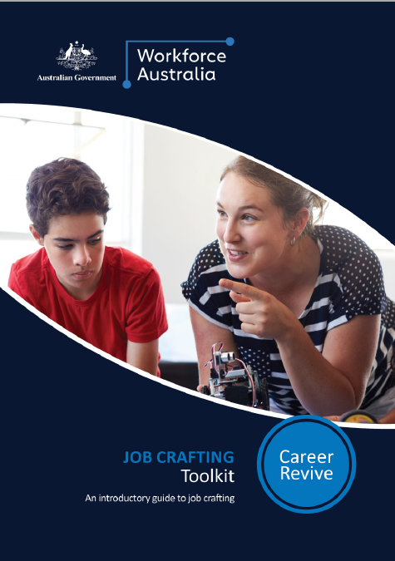

Contents

Toolkit Overview 3

Introduction to Job Crafting 5

Job Crafting: Beyond Job Design 6

A Practical Approach to Job Crafting 7

Forms of Job Crafting 8

Crafting Your Role: Selena’s Story 9

Identify Your Strengths 10

Visualise Your Role 11

Talking To Your Manager 12

Ensuring Job Crafting Success 14

Job Crafting Enablers 15

Set Yourself Up to Job Craft Successfully 16

A warning about Job Crafting 17



# Toolkit Overview

The war for talent has placed employee retention front of mind for Australian businesses. Job crafting is one way to achieve this, allowing individuals to change their tasks, relationships, and perceptions of their roles.

Introduction

Job crafting is an intentional activity undertaken by people to personalise their approach to work through the redesign and shaping of elements of their role.

It is one of many practical strategies that organisations have adopted to improve wellbeing, engagement and performance and enhance wellbeing and development.

The need to create an environment which allows people to express their whole self at work and utilise their diverse strengths, passions and interests will increase as the work environment continues to evolve.

Maximising individual strengths and talents becomes even more critical as the future of jobs and work increases the need for agility and flexibility within the workplace.

Toolkit purpose

This toolkit helps individuals to experiment with job crafting in their role or with their team.

The document outlines the core elements of job crafting and includes practical tools and processes to support individuals to re-craft their roles.

Who is this toolkit for?

This toolkit is a resource for individuals who are interested in exploring job crafting.

*Insights and observations have been drawn from leading practice research and the Career Revive Program. Career Revive is an Australian Government initiative aimed at supporting Australian businesses to attract and retain skilled women following a career break.*

“When I first came here, we started using the new higher-speed equipment. Then lots of new guys came in. So I started helping them learn the job. Now it’s just expected that I train the new guys. I did this in my previous job, so I have experience with it, and I like it because I’m able to help and work with guys from different backgrounds.”

MAINTENANCE TECHNICIAN AND JOB CRAFTER



# Introduction to Job Crafting

Job crafting can be a powerful tool to help individuals increase autonomy, creativity, and ownership of their jobs.

What is job crafting?

Job crafting is a bottom-up approach to finding your purpose at work. Importantly, it is a shift from your organisation saying what your job is, to you taking charge and personalising your work.

Traditional approaches to enhancing the employee experience have focused on initiatives driven at the enterprise level, such as introducing a hybrid work policy or additional professional development.

Another common approach is for managers and HR teams to re-design job descriptions or role profiles. While useful, these approaches minimise the power that individuals have to design roles and experiences that fit their needs, values and preferences.

Why job craft?

As well as increased productivity, job crafting also enhances employee wellbeing, increased autonomy, and job satisfaction as important outcomes for individuals and organisations.

Research, both Australian and international, indicates job crafting is directly linked to greater levels of work engagement (both as a precursor and a consequence of engaging in job crafting), job satisfaction, job performance, productivity, and retention.

Even those jobs which are more ‘routine’ and ‘restrictive’ have been shown to have increased employee wellbeing when workers are able to engage in job crafting behaviours.

“I was given the opportunity to craft a role that meant I was able to do what I love without leaving the team I love. Now I get to work directly with my customers to design their systems.“

PAST CAREER REVIVE PARTICIPANT

“When we are no longer able to change a situation, we are challenged to change ourselves.”

VICTOR FRANKL, MAN’S SEARCHFOR MEANING

Recommended Resources

|  |  |
| --- | --- |
|  | [Turn your boring job into a job you love.](https://hbr.org/2021/02/turn-your-boring-job-into-a-job-youll-love)  Dan Cable on job crafting. |
|  | [Ted Talk: Why some of us don’t have one true calling.](https://www.ted.com/talks/emilie_wapnick_why_some_of_us_don_t_have_one_true_calling#t-397942)  Emilie Wapnick describes how to job craft and career craft. |

# Job Crafting: Beyond Job Design

Job crafting is the next step beyond job design. The focus is on crafting meaningful work and opportunities for individuals to grow and learn in ways that suit them.

The typical approach to job design is to design top-down. In these cases, managers or HR design jobs for their employees based on what they need to get done to meet the goals of the organisation. Even inclusive job design, where there is greater focus on individual needs, is dependent on managers creating roles that fit within a pre-determined organisational framework.

The diagram below provides an overview of the similarities and differences of job crafting and job design.

|  |
| --- |
| **SIMILARITIES** |
| * Roles must fit within the broader organisation strategy and objectives. |
| * Employees feel personally responsible for the work they produce and understand the significance of their work within the broader business. |
| * Job design and job crafting can both introduce greater variety into roles, enhancing employee engagement and job satisfaction. |
| * Additional flexibility (such as hybrid work or reduced hours) can be introduced through job design and job crafting. |
| **DIFFERENCES** |
| * Job crafting is driven by the employee, rather than through management decisions. This builds more accountability into their role within the organisation. |
| * Job design is a formal process utilised by HR and managers, while job crafting can be done without organisational input. This increases employee engagement and satisfaction without relying on others in the organisation for input or to make decisions. |
| * Job crafting enables employees to choose specific tasks that align with their values and motivations. |
| * Job design may rely on past practice to understand roles in the organisation, while job crafting invites innovation and new ways of conceiving roles. |

# A Practical Approach to Job Crafting

## Forms of Job Crafting

There are three ways you can reshape your role to be more meaningful and engaging. You can choose to adopt one, or a combination or methods to recraft your role.

**Cognitive Crafting:** In this instance, you begin by reframing what you think about work, creating a new narrative for your role that feels personal and meaningful.

Ask yourself: How can I create a ‘purpose story’ that feels personal and meaningful to me?

**Task Crafting:** In this instance, you experiment with the type, scope, sequence or number of tasks done at work. By choosing to do fewer, more, or different tasks than are in their formal job, you can create a different job that is more aligned with their motivations and values.

Ask yourself: How can I bring in tasks that will generate energy and enhance my work process?

**Relational Crafting:** This form of crafting involves altering the quality and/or frequency of interaction with others at work. In this instance, you decide how often they interact with others, who they interact with, and the quality of these interactions.

Ask yourself: How can I focus on, and invest more time in the relationships that inspire me and my work?

*See page 9 for an example on how to apply these three job crafting behaviours in practice.*

|  |  |  |  |
| --- | --- | --- | --- |
|  | COGNITIVE CRAFTING  Altering how you interpret tasks and their broader purpose | TASK CRAFTING  Altering the type, scope, sequence and number of tasks that make up your work | RELATIONAL CRAFTING  Altering who you interact with and who you learn from in your work |
| **Example** | A construction worker chooses to think of their job in two separate parts: one part is the mundane administration; the other part is meaningfully contributing to building a family’s future home. | Design engineers tailoring a process to best suit their needs, capacity and capability to achieve the desired output. | Hospital cleaners actively caring for patients and families through the work they do; integrating themselves into the workflow of their hospital. |
| **Effect on meaning of work** | Changing how we view our job in this way fundamentally changes how we approach it. There is acknowledgement that some aspects of a role will always be less enjoyable but there is also a more meaningful aspect, which is *why* we do the work. | Work is completed in a timely manner as the number, scope, or completion of tasks are adapted to suit your way of working.  You can change the meaning of your job to be a ‘guardian’ or movers of projects, rather than viewing your contribution as a single stage. | By interacting with patients and medical staff, you can change the meaning of your job to be helpers of the sick and see yourself as an integral part of the patient care cycle. |

**Adapted from: Wrzesniewski&Dutton, 2001, p. 185**

## Crafting Your Role: Selena’s Story

Selena is in sales and has been in her customer-facing role for 18 months. She has had a conversation with her manager about taking on more responsibility and is interested in building the capability of her team, but isn’t sure how to fit this into her current role.

Follow Selena’s journey to craft the job she wants at her current organisation. Navigate through the steps she takes to find tools and templates for you to use on your own journey.

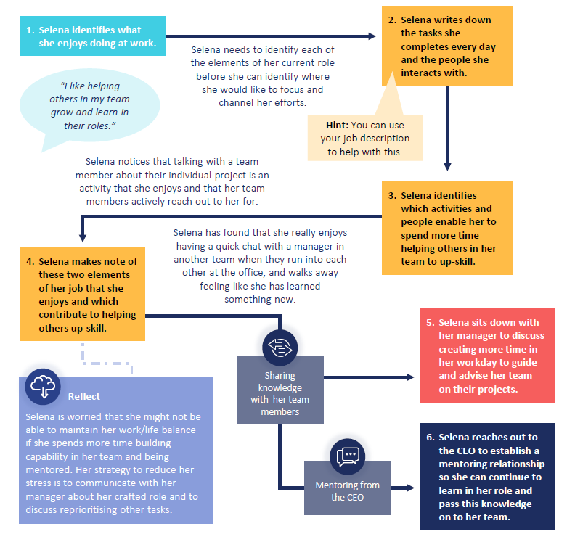

## Identify Your Strengths

Identifying your strengths (if you don’t already know them) and areas of enjoyment is an important step to make sure you craft your job into one which brings you joy. The prompt questions below can help you navigate this process.

What tasks or activities at work make me lose track of time?

|  |
| --- |
|  |

What do my co-workers rely on me most for?

|  |
| --- |
|  |

What am I working on right now that I’m excited about?

|  |
| --- |
|  |

What is an accomplishment that I’m proud of? Why?

|  |
| --- |
|  |

What is a task or behaviour that I have received positive feedback for?

|  |
| --- |
|  |

Your strengths, passions and motivations may change overtime. The activities and items you have listed here are a starting point for you to reflect on your role. Consider taking the time each day to think about what brings you joy at work and how you can keep doing it.

## Visualise Your Role

The template below can be used to visualise the tasks you undertake and interactions you have in your role day-to-day.

To help you think about how you can ‘craft’, once you’ve identified the tasks you do and the people you work with / learn from / talk to, reflect on which of those you want more or less of.

|  |  |
| --- | --- |
| **Tasks I do** | People I interact with |
|  |  |
| **Tasks I want to do more** | **People I want to interact with more** |
|  |  |
| **Tasks I want to do less** | **Tasks that I can deprioritise/ Am spending too much time on** |
|  |  |

## Talking To Your Manager

You can use this template to plan out the conversation with your manager about your crafted job.

|  |
| --- |
| **How are you crafting your role? What, if anything, is changing about how you like to work?** |
|  |
| **How has / will your crafted job enhance your experience at work?** |
|  |
| **How has / will your crafted job add value to your team and / or organisation?** |
|  |
| **What, if anything, does your manager need to do to support you?** |
|  |



# Ensuring Job Crafting Success

## Job Crafting Enablers

While job crafting is driven by the individual, the performance environment must be geared toward safety, experimentation and trust to encourage and support individuals to experiment with their roles.

The five areas outlined below are critical to promote job crafting behaviours.

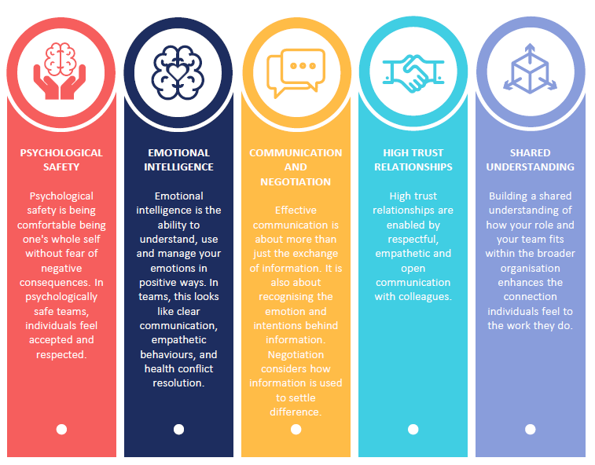

By utilising the above “crafting supplies”, organisations can foster job crafting behaviours. Individuals need to feel comfortable and confident to experiment and ask questions or talk through challenges as they arise. Without these workplace characteristics, job crafting can occur in isolation, impacting the experience of the individual at work and how the organisation achieves its goals.

## Set Yourself Up to Job Craft Successfully

Take a moment to answer the questions below. If answers are positive, the more likely your job crafting journey is to be supported by leaders and team members.

If you identify gaps in your team, consider talking to your manager or leadership group about how to enhance these areas.

|  |
| --- |
| ENABLING JOB CRAFTING CHECKLIST |
| PSYCHOLOGICAL SAFETY |
| * Are your unique skills and talents valued and utilised in this team? |
| * Is it safe to take a risk in this team? |
| * Are members of this team able to bring up problems and tough issues? |
| EMOTIONAL INTELLIGENCE |
| * Do your team members and manager display professional actions and behaviours during stressful periods of work? |
| * Does your manager take time to teach you and contribute to your professional development? |
| * Do you receive recognition and appreciation for the work you do? |
| HIGH TRUST RELATIONSHIPS |
| * Is it difficult to ask other members or the manager of this team for help? |
| * Do you feel comfortable sharing stories from your personal life with your team? |
| * Are you trusted to carry out your day-to-day role autonomously? |
| COMMUNICATION AND NEGOTIATION |
| * Do you have access to the information you need to complete your work? |
| * Do you feel comfortable when discussing your performance with your manager? |
| * Is team communication and discussion respectful? |
| SHARED UNDERSTANDING |
| * Do you know how your team’s function contributes to the organisation as a whole? |
| * Think about what values are important to you. Do they align with the values of your organisation? |
| * Are you proud to tell people where you work and why? |

## A warning about Job Crafting

It is worth a reminder that job crafting will not magically fix issues related to engagement at work. Without the right conditions, individuals and organisations can experience poor job crafting outcomes.

Being aware of the limitations of job crafting can help you plan for and mitigate any barriers you may come across.

|  |  |
| --- | --- |
|  |  |
| Job crafting may lead to inefficiencies in a team.  If job crafting starts to incorporate tasks or activities that overlap with or contradict those that are already occurring within the team, this can lead to frustration, decreased productivity and poor team culture. | If an individual leaves the organisation, the role that they have crafted for themselves may not suit their replacement.  Job crafting is driven by individual values, motivations and strengths, which may not align to those held by others. Roles which have been crafted to suit the individual may need to be crafted again for an incoming employee, changing the way the work is completed and how the rest of the team view the role. |
|  |  |
| Job crafting may result in individuals working beyond their agreed remuneration point or Enterprise Agreement.  An employee may craft their role into one which goes beyond their agreed salary or conditions. This can have legal implications and introduce tension between the employee and organisation. | Job crafting, particularly task crafting, may result in a higher-than-anticipated workload.  Sustained overwork can lead to burnout, fatigue, stress, and other health impacts for the individual. |
|  |  |
| When individual and organisation goals are not in alignment, both the individual and organisation can have a poor experience of job crafting.  In some cases, individuals may be more interested in fulfilling personal goals, rather than engaging with organisational goals. This misalignment will lead to conflict and have a direct impact on the relationship the individual has with the organisation. | |
|  | |